

**Green University of Bangladesh**

**Department of Computer Science and Engineering (CSE)**

**Semester: (Spring, Year:2024), B.Sc. in CSE (Day)**

**Lab Report NO #05**

**Course Title: Database System Lab**

**Course Code: CSE 210 Section: 221 D1**

**Lab Experiment Name:** Implementation of Relational Databases (Join Function)

**Student Details**

| **Name** | | **ID** |
| --- | --- | --- |
| **1.** | Tanvir Ahmed | 221002461 |

**Lab Date : 13/5/2024**

**Submission Date : 20/5/2024**

**Course Teacher’s Name : Dr. Faiz Al Faisal**

| **Lab Report Status**  **Marks: ………………………………… Signature:.....................**  **Comments:.............................................. Date:..............................** |
| --- |

**1. TITLE OF THE LAB REPORT EXPERIMENT**

Implementation of Relational Databases (Join Function)

**2. OBJECTIVES/AIM**

* To create a database
* To create tables in the database
* To insert data into each table
* To Implement the Lab Exercise using the join function.
* Show the outputs of change.

**3. PROCEDURE**

* At first, we created a database named lab8.
* Then create some tables based on the lab exercise problem.
* Now insert data on each table.
* Implement two lab exercises using the join function.
* Show the final outputs..

**4. IMPLEMENTATION**

Source Code:

1. Creating a Database:

CREATE DATABASE lab8;

1. Creating Tables:

USE lab8;

CREATE TABLE salesman (

salesman_id INT PRIMARY KEY NOT NULL,

name VARCHAR(50),

city VARCHAR(50),

commission DECIMAL(4, 2));

CREATE TABLE customer (

customer_id INT PRIMARY KEY NOT NULL,

cust_name VARCHAR(50),

city VARCHAR(50),

grade INT,

salesman_id INT);

CREATE TABLE orders (

ord_no INT PRIMARY KEY,

purch_amt DECIMAL(10, 2),

ord_date DATE,

customer_id INT,

salesman_id INT);

1. Inserting data on the tables:

USE lab8;

INSERT INTO salesman VALUES

(5001, 'James Hoog', 'New York', 0.15),

(5002, 'Nail Knite', 'Paris', 0.13),

(5005, 'Pit Alex', 'London', 0.11),

(5006, 'Mc Lyon', 'Paris', 0.14),

(5003, 'Lauson Hense', NULL, 0.12),

(5007, 'Paul Adam', 'Rome', 0.13);

INSERT INTO customer VALUES

(3002, 'Nick Rimando', 'New York', 100, 5001),

(3005, 'Graham Zusi', 'California', 200, 5002),

(3004, 'Fabian Johnson', 'Paris', 300, 5006),

(3007, 'Brad Davis', 'New York', 200, 5001),

(3009, 'Geoff Cameron', 'Berlin', 100, 5003),

(3008, 'Julian Green', 'London', 300, 5002),

(3001, 'Brad Guzan', 'London', NULL, 5002),

(3003, 'Jozy Altidore', 'Moscow', 200, 5007);

INSERT INTO orders VALUES

(70001, 150.50, '2012-10-05', 3005, 5002),

(70009, 270.65, '2012-09-10', 3001, 5005),

(70002, 65.26, '2012-10-05', 3002, 5001),

(70004, 110.50, '2012-08-17', 3009, 5003),

(70007, 948.50, '2012-09-10', 3005, 5002),

(70005, 2400.60, '2012-07-27', 3007, 5001),

(70008, 5760.00, '2012-09-10', 3002, 5001),

(70010, 1983.43, '2012-10-10', 3004, 5006),

(70003, 2480.40, '2012-10-10', 3009, 5003),

(70012, 250.45, '2012-06-27', 3008, 5002),

(70011, 75.29, '2012-08-17', 3003, 5007),

(70013, 3045.60, '2012-04-25', 3002, 5001);

1. 1st Problem:

USE lab8;

SELECT

o.ord_no as Order_Number,

o.ord_date as Order_Date,

o.purch_amt as Amount_of_Order,

c.cust_name as Customer_Name,

s.name as Salesman_Name,

s.commission as Commission_Rate

FROM orders as o JOIN customer as c ON o.customer_id = c.customer_id JOIN salesman as s ON c.salesman_id = s.salesman_id;

1. 2nd Problem:

USE lab8;

SELECT

c.customer_id,

c.cust_name as Customer_Name,

c.grade,

s.name as Salesman_Name

FROM customer as c LEFT JOIN salesman as s ON c.salesman_id = s.salesman_id ORDER BY c.customer_id ASC;

**5. TEST RESULT / OUTPUT**

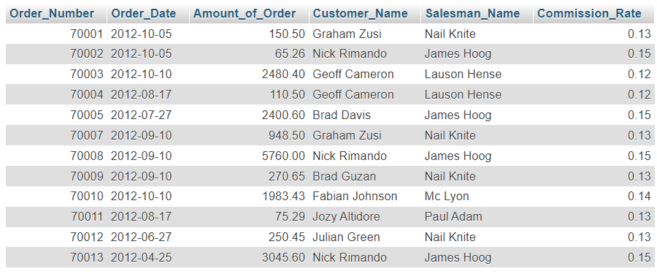

fig1. First Problem Output.

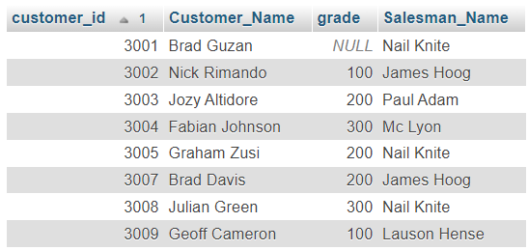

fig2. Second Problem Ouput.

**6. ANALYSIS AND DISCUSSION**

* In this exercise, the database called ‘lab8’ was first successfully created.
* Then we created some tables based on the lab exercise given in the lab manual.
* We insert information into each table using INSERT INTO statements.
* I solve the exercises using the appropriate join function and other functions of SQL.
* Screenshots showing all the outputs based on the exercise.

**7. SUMMARY**

This lab exercise demonstrates practical applications of SQL Relational Databases especially join functions I learned from the previous class. I implemented the exercise by creating a database, and tables, inserting data into each table from the lab manual, and showing outputs based on the exercise needs. The output comes perfectly.